Fundamentals of Software Engineering

Deliverable 2

AI-Based Road Sign Detection for Pakistani Road Users & Stakeholders

# Members

Isaam Ansari 21I-0299

Hasnain Jafri 21K-3116

Shehroz Ali 21I-0252

Hamzah Ahmed 21I-0254

# Glossary

**Members 1**

**Glossary 1**

**Links 2**

Trello - Trello 2

Figma - Figma 2

Github - Github 2

Sprint Meeting Recording- Drive Link 2

**Snapshots - Trello 3**

Snap-1 3

Snap-2 4

Snap-3 4

**Burn-down chart 5**

**Github Repository Screenshot 5**

**Sprint 2 Planning 6**

User Stories & Substories (including Sprint 1 backlog) 6

History Log 6

User Registration 6

Audio Engagement 7

Theme Change Functionality 7

Switch User 8

User Dashboard 8

Data Collection 8

Respective Tasks & Estimates 9

User Registration 9

History Log 9

Switch User Functionality 9

User Dashboard 9

Theme Functionality 9

Audio Engagement 9

Data Collection 9

# **Links**

## Trello - [Trello](https://trello.com/invite/b/rfOonuhb/ATTId85678cea5bc21c06e97bc36a80578274989A251/project)

## Figma - [Figma](https://www.figma.com/proto/Q8udiXG32Qk570NZlEfKOy/Traffic-app?page-id=7%3A485&node-id=7-485&viewport=368%2C128%2C0.1&scaling=scale-down&starting-point-node-id=813%3A150)

## Github - [Github](https://github.com/hasnainjafri20/FOSoftware-Eng-Project)

## Sprint Meeting Recording- [Drive Link](https://drive.google.com/file/d/1_RhXqJupXHnXDTXIjNMZuy4IeA93fAHn/view?usp=share_link)

# **Snapshots - Trello**

## Snap-1

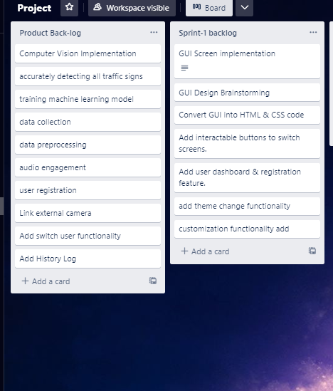

## Snap-2

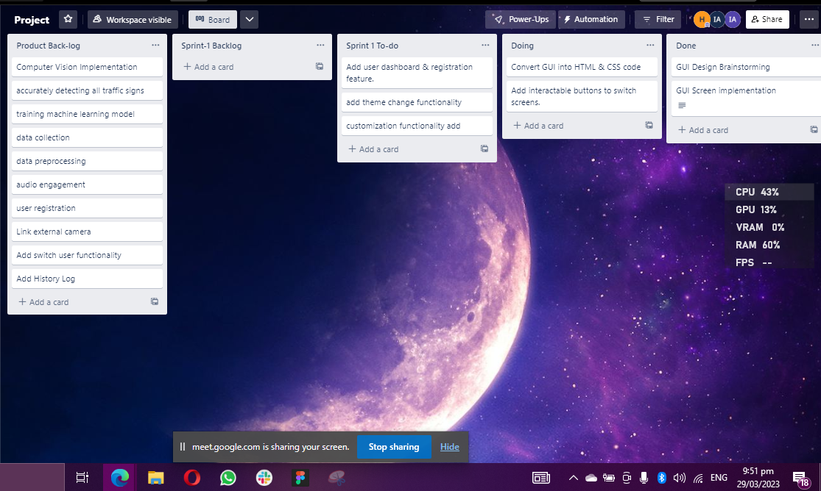

## Snap-3

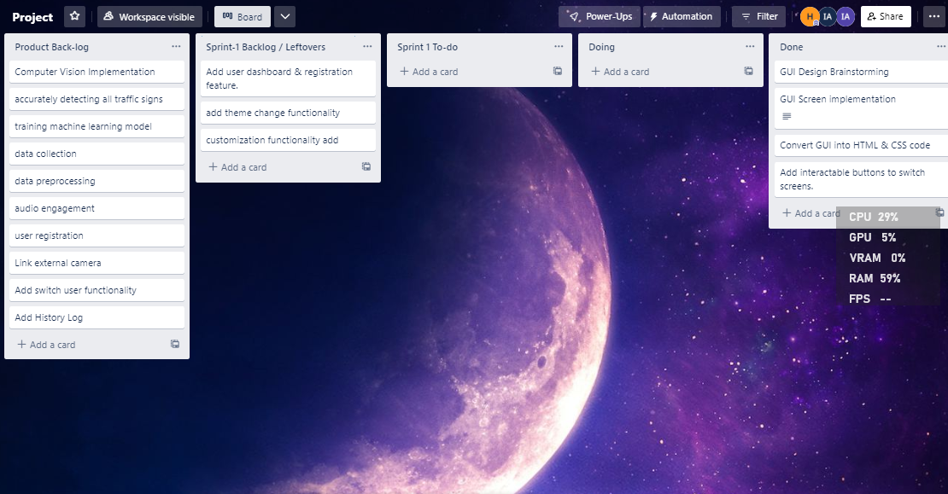

# Burn-down chart

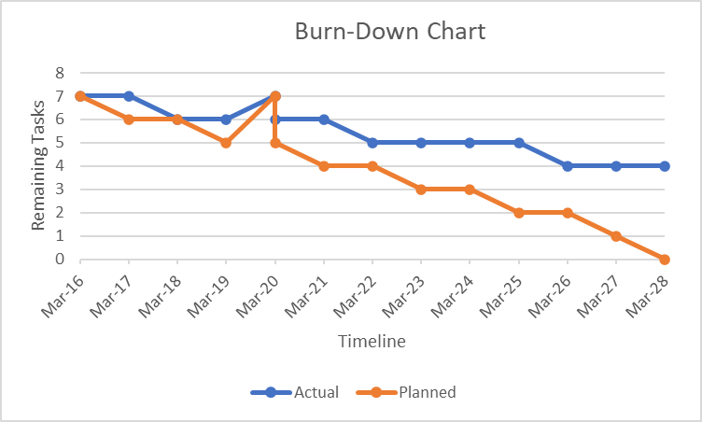

# Github Repository Screenshot

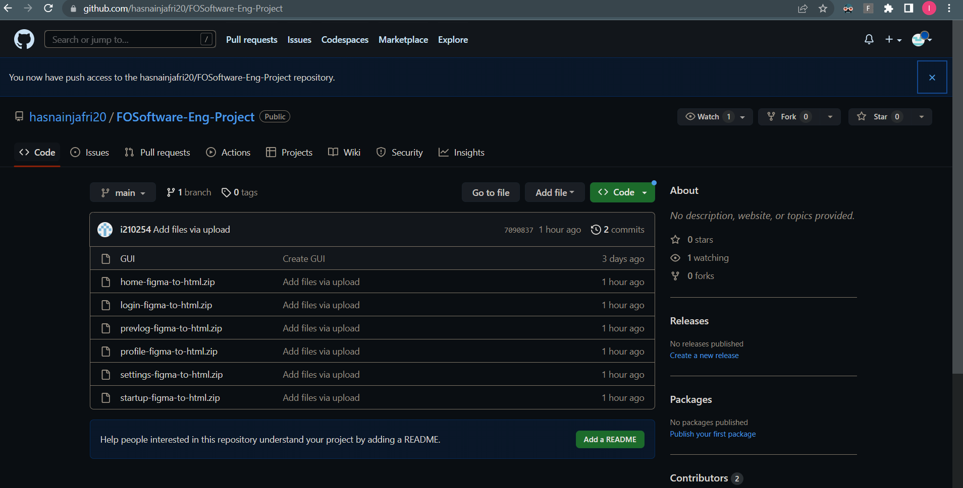

# Sprint 2 Planning

## User Stories & Substories (including Sprint 1 backlog)

### History Log

| Story Title: History log | | |
| --- | --- | --- |
| Story | As a user,  I want to keep a log of all the traffic signs that I have passed through. | |
| Acceptance Criteria | To be able to show all the previous detected traffic signs. | |

### User Registration

| Story Title: User Registration | | |
| --- | --- | --- |
| Story | As a user,  I want to register for the app so that I can access its features and functionality | |
| Acceptance Criteria | To be able to take the client's complete name, email address, and other necessary information and after taking them redirect them to the main page where they can use the app’s features. | |

### 

### Audio Engagement

| Story Title: Audio Engagement | | |
| --- | --- | --- |
| Story | As a user,  I want the app to tell me in speech about the detected signs, to provide warning beeps and other forms of sensory engagement | |
| Acceptance Criteria | To be able to detect the road signs and tell the users in the form of beeps and speech. | |

### Theme Change Functionality

| Story Title: Theme Change Functionality | | |
| --- | --- | --- |
| Story | As a user,  I want to be able to change the themes of the app according to my liking, | |
| Acceptance Criteria | The availability of multiple theme options, the ability for users to choose and use their preferred theme, ensuring that the selected theme is applied consistently throughout the app, storing the user's selected theme preference for future sessions, and displaying a confirmation message upon successful application of the selected theme should all be included in the acceptance criteria for the theme change functionality. | |

### 

### 

### Switch User

| Story Title: Switch User | | |
| --- | --- | --- |
| Story | As a user with multiple accounts, I want to be able to switch between my accounts easily and securely. | |
| Acceptance Criteria | The display of a list of available user accounts, the ability for the current user to log out and switch to a different user account, the assurance that switching users clears any user-specific data and preferences, and the display of a confirmation message upon successful switch to the selected user account should be the acceptance criteria for the switch user functionality. | |

### User Dashboard

| Story Title: User Dashboard | | |
| --- | --- | --- |
| Story | As a user,  I want to have a dashboard that provides an overview of my account and my activity | |
| Acceptance Criteria | The user dashboard feature must show an overview of the user's account information and activity, allow customization of the dashboard's widgets or sections, and be simple to use with intuitive controls and clear labeling. | |

### Data Collection

We will collect and arrange images to train our AI model for detecting traffic signs. To ensure the accuracy and robustness of our model, we must compile a sizable and diverse collection of traffic sign images from various sources. The pictures depict highways, city streets, and rural areas. We will try to accurately tag these images with relevant metadata. By following best practices for data collection, we can create a traffic sign detection model that is trustworthy and accurate and contributes to improving traffic efficiency and safety.

## Respective Tasks & Estimates

### User Registration

Estimated Time: 5 days

### History Log

Estimated Time: 5 days

### Switch User Functionality

Estimated Time: 3 days

### User Dashboard

Estimated Time: 7 days

### Theme Functionality

Estimated Time: 4 days

### Audio Engagement

Estimated Time: 7 days

### Data Collection

Estimated Time: 10 days